**OVERVIEW**

NRCS conservation planners follow the nine-step conservation planning process to identify resource concerns and objectives, inventory and analyze data on resource conditions, formulate and evaluate alternatives for conservation treatment, make informed decisions, and implement and evaluate conservation plans (see the National Planning Procedures Handbook, Handbook 180, Part 600). To support the process, NRCS specialists develop methods and tools based on scientific research and modeling techniques designed for each resource concern.

The Conservation Assessment Ranking Tool (CART) streamlines existing NRCS assessment tools and methods to support NRCS conservation planners in their work with clients. CART facilitates the conservation planning process to assist conservation planners as they analyze existing resource conditions, assess site vulnerability, and formulate and evaluate alternative actions.

The NRCS conservation planning process uses planning criteria, specified for each resource concern, as a guidepost for setting conservation goals. Similarly, CART uses thresholds that represent whether planning criteria have been achieved, or, if additional conservation practices are necessary to meet them. CART also captures information to help prioritize program funding and provide a menu of financial assistance program options to support implementation.

By uniting tools already used in the conservation planning process, CART provides a streamlined framework to assess identified resource concerns. Resource concern assessment is a result of the planner’s interaction and site visit with a client. The assessment considers the client’s conservation objectives and the site’s needs. Consistent with progressive planning, a planner may choose to assess and document a subset of resource concerns. The CART assessment is designed to document identified resource concerns and estimate how existing and planned conservation practices and activities help meet NRCS planning criteria and client objectives.

CART provides a configurable system to evaluate geospatial information along with planner-entered data. Every field is evaluated for key site characteristics that affect identified resource concerns. A threshold score is set for each identified resource concern to represent the effort needed to attain a target level of conservation using conservation actions. Sites are then evaluated for existing management and conservation efforts (the “existing condition”) and compared to the threshold to determine the level of conservation effort still needed.

CART is designed to enable the planner to override the existing and planned condition results. The override function should be used in cases when CART questions, information, and analysis framework do not align with planners’ observations, or another assessment method.

**CART METHODOLOGIES**

The goal for CART is to unite existing NRCS tools and methods that address resource concerns under a common framework by creating a system of relative points. The relative points represent effectiveness of conservation actions and can be used to compare whether current management on the land, given its unique vulnerabilities and characteristics, meets the needs of each identified resource concern, i.e. NRCS planning criteria or CART thresholds (see Figure 1). The same system enables comparisons of relative benefits of conservation actions and their relative effectiveness in treating each identified resource concern.

**Figure 1. The CART framework and its relationship to the NRCS conservation planning process.**

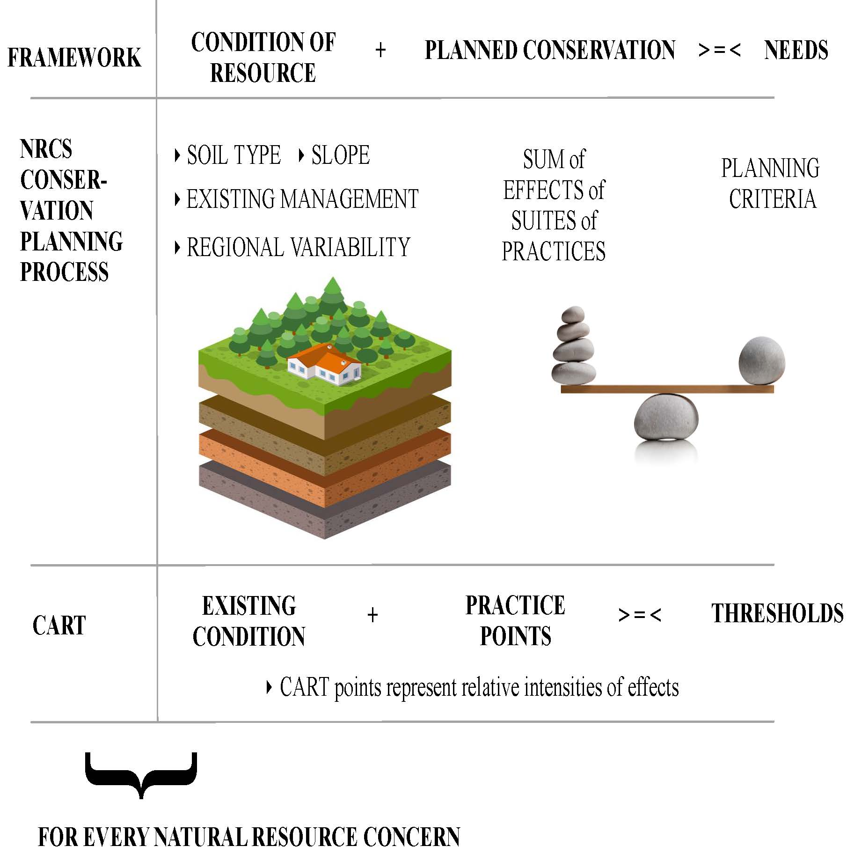

CART starts with the NRCS National Resource Concern List and Planning Criteria (NI 450-309.20). Each of the NRCS resource concerns has an associated land use, an objective that relates to the planning criteria, a process for evaluating the concern’s severity, and a method for establishing the planning criteria.

The sophistication and accuracy of the available tools and methods varies by resource concern. For some resource concerns, like sheet and rill erosion, tool development started nearly a century ago and has continuously progressed. Tools for estimating nutrients transported to ground and surface waters developed out of erosion computer processing models; they link several datasets to estimate conservation practice effectiveness to prevent losses of nutrients. Ephemeral and classic gully erosion rely on the observations of trained conservation professionals. To unite disparate tools, CART’s common framework uses three steps.

First, using geospatial information, planners’ observations, and/or modeling estimates, CART assists planners in undertaking a thorough evaluation of current natural resource conditions. For every resource concern that is selected, CART assigns either a fixed or a variable threshold to represent the need for conservation.

Second, CART assigns points to conservation practices[1] to represent relative intensities of effects on identified natural resource concerns. Choosing different combinations of practices (conservation systems) allows users to estimate how analyzed alternatives impact results.

Third, within CART, planners can add current and planned management systems and evaluate them against the thresholds to assess how effective the operation’s conservation system is in meeting NRCS planning criteria. When an effective conservation system requires supporting conservation practices, the planner can add them within CART. Supporting practices will not add conservation management points to the total. A comprehensive list of practices and their points toward addressing each resource concern by land use is titled the Conservation Assessment Practice Points (CAPP) table.

The formula below shows the ideal framework for designing CART assessments for resource concerns (see Figure 1).

*When existing condition points + Planned Practice points < Threshold: resource concern exists and needs treatment*

*When existing condition points + Planned Practice points ≥ Threshold: resource concern is adequately treated*

The majority of resource concerns will have a threshold of 50, representing the NRCS planning criteria for that resource concern. If the existing condition is below 50, then the assessment threshold is not met. If the existing condition is at or above 50, then the assessment threshold is met (see Figure 1). In some cases, geospatial interpretations will be available to help set the threshold. In these situations, the variable threshold communicates a higher or lower risk or priority for the site, likely requiring additional or less conservation respectively.

**CART & “TRADITIONAL” ASSESSMENTS**

CART streamlines our existing tools and methods with a focus on capturing the key elements of the resource condition and current site management. Assessments of resource concerns in CART should closely reflect "traditional" resource assessments.

Accordingly, many of the tables in this document with CART questions, answers, and corresponding points reference the latest versions of processes outside of CART (such as the In-Field Soil Health Assessment, Pasture Condition Score, Determining Indicators of Pasture Health, Interpreting Indicators of Rangeland Health, etc.) to illustrate the shared foundations used to develop CART. The reference does not imply that an outside tool needs to be used in conjunction with CART. Indeed, in most instances, an experienced conservation planner would not need to run another tool to complete a CART assessment.

Planner knowledge, results from other assessment methods (tools, observations, client input, etc.) indicated in the NI 450, part 309.20 national planning criteria guide, recommendations available from partners and local, state, or federal policies are appropriate for use in selecting answers for CART.

1. Future iterations of CART will take a systems-wide approach and assign points to conservation practices based on their relative effectiveness to contribute to functional groups, where functional groups represent functions – developed for each resource concern – that successful conservation systems must perform to meet that natural resource’s treatment needs.